Université d’Abomey-Calavi
Laboratoire de Biomathématiques et d’Estimations
Forestières (LABEF)

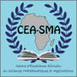
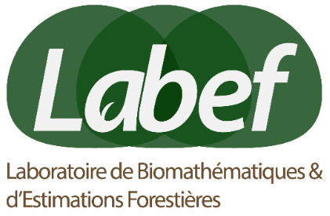
The African Mathematical School of Abomey-Calavi (Benin), 22 – 28 january 2018

Calls for Application & Application form
The Laboratoire de Biomathématiques et d’Estimations Forestières (LABEF) of the Université d’Abomey-Calavi (UAC) organizes from 22 to 28 january 2018 at Abomey-Calavi, with the support of the International Center for Pure and Applied Mathematics (ICPAM), a workshop titled
« African Mathematical Schools »,
THEME : « mathematical modeling for epidemiology,
ecology and conservation»

The African Mathematical School of Abomey-Calavi aims to:

- Organize discussions about skills on « population matrix models » and « mixed effects models ».

- Identify some appreciate students and provide them with possible opportunities to make doctorate studies

- Establish collaboration between scientists of Africa, Latin America and Europa about the school themes.

The school will take place through conferences (courses), controlled works, lectures, studies of mini-projects and some tourism.

Five courses will be delivered by lecturers from various horizons:

Lecture I : Introduction to mathematical modeling, Prof Aboubacar Marcos, IMSP, University of Abomey-Calavi, Benin.

Lecture II : Dynamical system, Prof Maria Leite, University of South Florida at St. Petersburg, Florida, USA/INRES.

Lecture III: Structured population models, Prof Orou Gaoue, Department of Ecology and Evolutionary Biology, University of Tennessee, Knoxville, USA.

Lecture IV: Linear mixed effects models, Prof Romain Glèlè Kakaï of LABEF, University of Abomey-Calavi, Benin.

Lecture V: Survival data analysis, Prof Kossi Gneyou of University of Lomé, Togo.

General Information:
The School with be held : 22 – 28 January 2018
Venue : Laboratoire de Biomathématiques et d’Estimations Forestières (LABEF), University of Abomey-Calavi

Communication Language: French and/or English

To show your interest to participate in this School, please fill the application form below and email it by December 15th, 2018 to : contact.labef@gmail.com

Complementary Contact Information : Dr Valère Kolawolé SALAKO
Tel: (00229) 95346579 ou (00229) 96172729 ; Mail : salakovalere@gmail.com

Application form of the
African Mathematical School of Abomey-Calavi
First Name …………………………………………………………………….
Family name …………………………………………………………………..
Sex………………………………………………………………………………..
Date and Place of birth………………………………………………………...
Level of Study……………………………………………………………………
Institute (College) …………………………………………………………........
City…………………………., Country:…………………….……...................
Phone. …………………………………………………………………….…….
E-mail …………………………………………………………………………….
Scientific Communication (Optional) …………………………………………
Title and summary of the communication:

